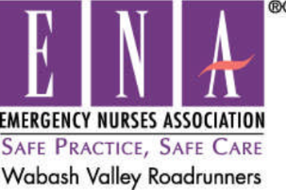

Scholarship Application
ENA Chapter 401

Name ______________________________________________________
(Last) (First) (Middle)
Home Address _______________________________________________
City/State/Zip ________________________________________________
Phone Number ____________________ Email _____________________
Course you wish to attend ______________________________________
ENA Number ________________________ Expiration Date __________

There will be a total of two (2) scholarships awarded each term. The scholarship may be awarded for up to the amount of $250 for an approved educational activity. Nurse/nursing student must be a current member of the ENA Chapter 40, and have attended at least two (2) meetings in the previous 12 months to be eligible. Scholarship may be used to attend any course, class, or conference that will lead to advancement in nursing education. The course, class, or conference must be approved by the Scholarship Committee. Reimbursement will be provided to the scholarship recipient once proof of course completion, expense form, and a receipt are returned to the ENA Chapter Treasurer. Applicants have one year to obtain the awarded scholarship. Scholarships are available to nurses at all levels: student nurses, ASN, BSN, Master’s, and Doctorate.

Requirements

1. A one (1) page essay on why you should be awarded the scholarship. Also include how
you will advance in your practice of emergency nursing due to involvement in the course or
conference.
2. Letter of reference from a current ENA member in good standing.
3. A current copy of your CV or resume.
4. A copy of this application and your EMA membership card.
5. A copy of the conference registration form, course information, or other information about the class
you wish to take.

Mail application to:
Carrie Malone
4394 N Walsh St
Linton, IN 47441

Deadline for first submission is March 1st. Scholarship will be awarded at April ENA Chapter 401 meeting.
Deadline for second submission is September 1st. Scholarship will be awarded at October ENA Chapter 401 meeting.

