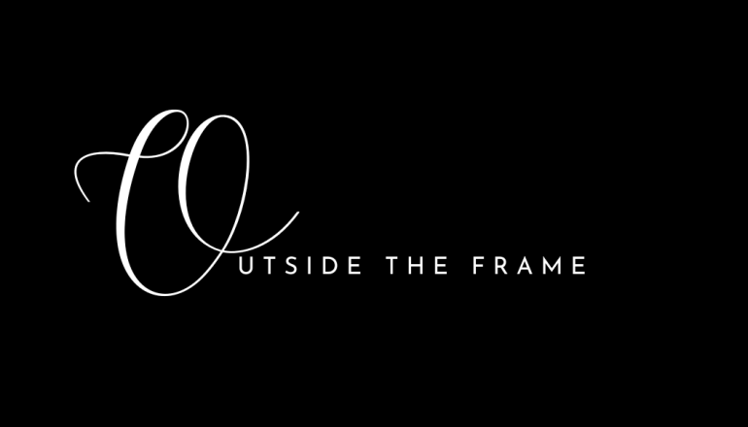

***“So never lose an opportunity of urging a practical beginning, however small, for it is wonderful how often in such matters the mustard seed germinates and roots itself.”***

***-Florence Nightingale***

Outside the frame is a one click access to resources for survivors of domestic and sexual violence in Marion and surrounding counties. In addition – it houses numerous resources for teen dating, sexual & mental health, human trafficking, addiction & substance abuse and more.

Outside the Frame was created and run by our Ascension St. Vincent Center of Hope forensic nurse team in hopes of getting lifesaving resources to those with the greatest need.

Questions or suggestions:

317.338.1956

Outsidetheframe.info@gmail.com

